Conservation Evidence Report

Wilder Blean
Natural processes: wild grazing herbivores
Kora Kunzmann
Wilding Evidence Ecologist
Kent Wildlife Trust, Tyland Barn, Sandling Lane, Maidstone, Kent, ME14 3BD

Survey leader: Kora Kunzmann
Survey type: Baseline monitoring
Date(s) of fieldwork: 17th – 21st January 2022
Date of report: April 2022
Version: FINAL

1 Project introduction
Wilder Blean is a wilding project in West Blean and Thornden Woods that is reintroducing large grazing herbivores to reinstate natural processes in a woodland ecosystem and monitoring the effects of these animals on the vegetation and the taxa this will in turn influence. The project is designed as an experiment involving three grazing assemblage treatments: 1) European Bison, Exmoor ponies and Iron-Age pigs; 2) Longhorn Cattle (in place of Bison), Exmoor Ponies and Iron-age Pigs, and 3) a control area where no introduced grazing animals will be present.
The Blean woodland complex to the north and west of Canterbury forms one of the largest surviving blocks of ancient semi-natural woodland in England. West Blean and Thornden Woods, which forms part of the Blean complex, is a mosaic of different habitat types as a result of extensive replanting. The oldest and most natural types are the Oak-Hornbeam community and mixed broad-leaved coppice with standards. Of more recent origin are extensive stands of Sweet Chestnut coppice. During the last 55 years or so, extensive areas of the woodland have been cleared and replaced with conifer plantations, some of which have since been thinned or felled. Within the woodland there are also small areas of heath and a few limited areas of wetland habitat, including natural features as well as man-made ponds.
Due to the Bison’s ecology and behaviour, the project is hoping to create more open areas and structural diversity and provide a nature-based, natural process led, and sustainable solution to woodland management in southeast England.

2 Survey aims
The aim of this part of the monitoring programme is to understand the baseline wild herbivore grazing pressure, in order to establish confidence in the extent to which habitat change can be attributed to effects of introduced animals.

3 Survey methodology
Transect routes were walked in January 2022 across all treatment areas. Four transects were walked in the bison area with an approximate total length of 3 km, three transects were walked in the livestock area with an approximate total length of 3 km, and one transect was walked in the control area with an approximate total length of 1.6 km. The transect routes were chosen in a way to make sure all five broad habitat types present in West Blean and Thornden Woods (coppice, high forest, native regeneration, open habitat and plantation) are represented evenly in all three treatment areas. The transect routes are shown in Figure 1 Wilder Blean project area with habitat baselines and deer transect.
The survey methodology followed the ‘Index of Deer Presence’ methodology of Mayle, et al. (1999). Each transect was systematically searched and the number of deer fecal pellet groups was recorded. All pellet groups found within 0.5 m either side of the transect line being walked were counted and identified to species, where possible. The mean number of pellet groups per 100m was calculated for each deer species and was used to establish a deer density per 100 ha, factoring in deer defecation and pellet decay rates.
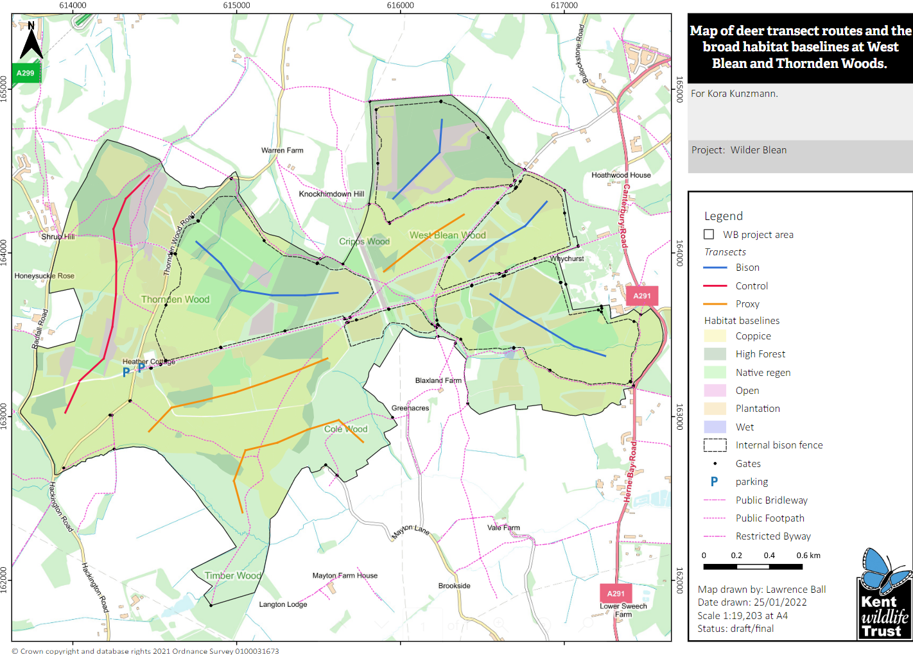
Figure 1 Wilder Blean project area with habitat baselines and deer transect routes in all three treatment areas

4 Results and analysis
Only one pellet group was found in the bison treatment and identified as Reeves’ Muntjac (Muntiacus reevesi) pellets. It was recorded on the northwestern bison transect. Three European Rabbit (Oryctolagus cuniculus) pellet groups were found in the livestock area, all of which on the southern transect route. These have been disregarded in the further analysis. No pellet groups were found in the control area. See Figure 2 for pellet group locations.
The mean number of muntjac pellet groups per 100m was 0.1 for the northwestern bison area and 0 for all other bison areas, the livestock area and the control area.
Considering a defecation rate of 7.5 pellet groups per day for Muntjac deer and a mean decay rate of 138 days (Mayle et al., 1999), a deer density of 1 per 100 ha has been established. Given a total project area of 549.7 ha, it is assumed that no more than 6 Muntjac deer are grazing across all three treatment areas, and that no other species of deer are present.
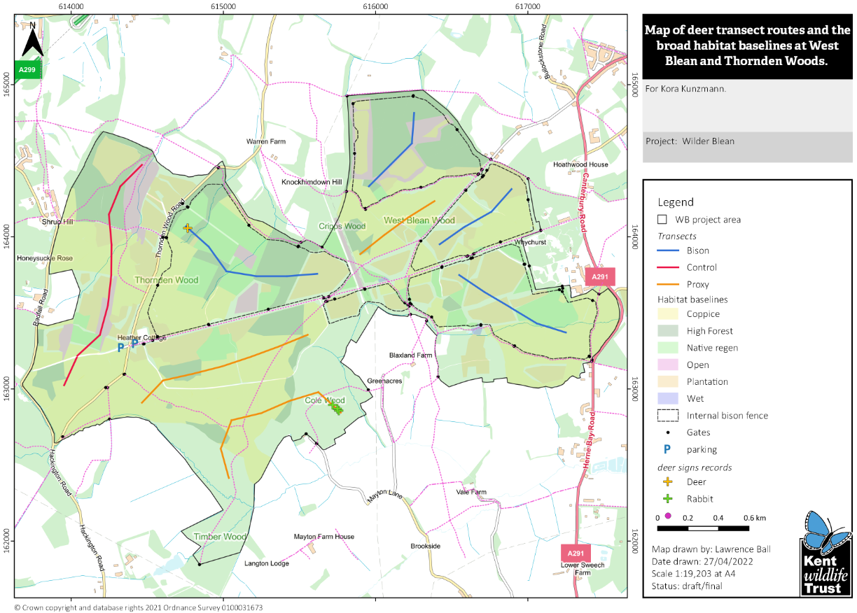
Figure 2 Wilder Blean project area with habitat baselines, deer transect routes and pellet group locations in all three treatment areas

5 Assumptions and Limitations
Small areas along the transects, in particular native regeneration habitat, were inaccessible due to dense young birch (Betula spp.), bramble (Rubus fruticosus) and heather (Calluna vulgaris). In these cases, the surveyor had to deviate from the transect route slightly whilst taking care to re-join the transect as soon as possible.
Roe deer (Capreolus capreolus) pellet decay rate for established woodlands (Mayle et al., 1999) was used in order to calculate deer density per 100 ha. No agreed Muntjac pellet decay rate could be found in existing literature, and it is beyond the scope of this survey to monitor the decay rate in West Blean and Thornden Woods.

6 Conclusion
Deer numbers are generally low in Kent with Muntjac only sparingly found in the county (Young et al., 2015). Whilst present in slightly larger numbers in other areas of the Blean woodland complex, the deer density for West Blean and Thornden Wood is particularly low, presumably due to the A2, A291 and A290 isolating the woodland from other areas of the complex. Given this low density, it is assumed that most of the grazing and browsing effects occurring over the next few years will be due to the Bison, Longhorn Cattle, Exmoor Ponies and Iron-age Pigs, rather than pre-existing naturally occurring grazers.
There are currently insignificant differences in mean pellet groups per 100 m and deer density between the bison, livestock and control area.
This survey is going to be repeated in 2026 as part of the Wilder Blean Monitoring Programme. Despite some of the project area being fenced in, deer immigration will be monitored periodically due to Muntjac being a fast-breeding species (Young et al., 2015) and the fact that the fences are not expected to present an impenetrable barrier to deer.

7 References
Mayle B. A., Peace A. J., Gill R. M. A. (1999). How Many Deer? A field guide to estimating deer population size. Forestry Commission, Edinburgh.
Young J. S., Ryan H., Thompson S., Newcombe M., Puckett J. (2015). Mammals of Kent. A mammal distribution atlas, account of surveys, recording and monitoring. Kent Mammal Group, Kent Bat Group, East Kent Badger Group and Kent Field Club, Broadstairs.

