Wilding Ecologists
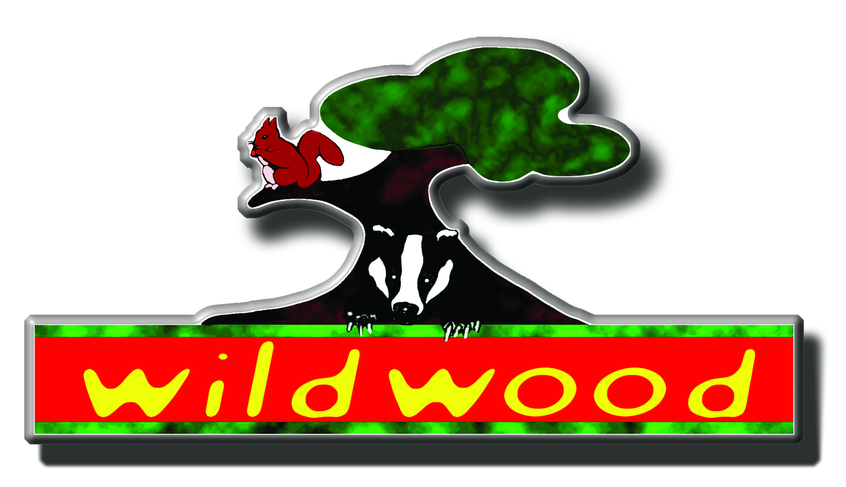

Job Title: Wilding Ecologist (full time)

Function: To explore, identify and deliver opportunities for engaging landowners and other organisations in projects to restore natural processes within key ecosystems and contribute to the delivery of landscape scale ecological recovery networks across Kent.

Responsible to: Wilder Landscapes Manager

Key relationships: other Wilding Ecologists; Reserves Managers; Reserves Wardens; Communications & Marketing, and Fundraising staff

Responsible for: Volunteers and contractors
Kent Wildlife Trust
Kent Wildlife Trust is a flexible employer that aims to be one of the best employers in the environment sector in the southeast. It is one of the largest of the 47 Wildlife Trusts, which together make up the Wildlife Trusts Partnership. We are supported and governed by our 32,000 members, and have the simple ambition of enabling the recovery of Kent’s wildlife. To this end, we own or manage some 65 nature reserves covering over 8,100 acres; we campaign and lobby politicians, decision makers and landowners to ensure site protection and good habitat management; and we run a full programme of education work with schools, colleges and adult groups. The Trust also has three Visitor Centres.

The Trust operates from its headquarters at Tyland Barn, just north of Maidstone. It is composed of over 100 professional and support staff who work within teams including Estates, Conservation Delivery & Partnership, Conservation Policy & Evidence, People Engagement, Marketing and Fundraising, Finance and Support Services.

Visit our website to see the range of our activities – www.kentwildlifetrust.org.uk.
Job Purpose

Conservation thinking is changing. The establishment of new ideas and concepts around less prescriptive and intensive management of ecosystems and component habitats are leading to a more ecological systems based approach focussed on the restoration of natural processes to tackle a range of natural, societal and economic challenges. These approaches are most visible in the re-wilding movement, advocating more extensive management of broad mosaics of habitats at a landscape scale, underpinned by the reintroduction of keystone species such as beaver.

We are looking for highly motivated individuals to join our new Wilder Landscapes Team, identifying opportunities for applying wilding techniques through engagement with landowners, partners and other conservation bodies whilst also supporting KWT staff in understanding and supporting the value of these techniques.

This full-time post is shared between KWT and our partners Wildwood Trust (WT) via a 1-day a week secondment to. The post-holder will support colleagues within the team and wider Trust with the implementation of existing projects, whilst contributing to the development of challenging new initiatives, and supporting our consultancy arm which delivers land advice, thereby extending the reach of the Trust as we strive to create a wilder Kent
.
The incumbent will help us to extend and grow our expertise of engaging with, and capturing the support of, local stakeholders who are key to delivering a diverse suite of pilot projects identified as part of new KWT strategy.

We welcome candidates who embrace these new concepts, are excited by exploring less traditionally prescriptive conservation management, are looking for an opportunity to grow within their role and are enthusiastic about working on a wide variety of interesting and innovative natural process restoration projects across the county.

Principal Duties
      - Identify, plan and deliver a range of natural processes & natural capital projects with landowners across Kent
- Liaise with KWT colleagues and stakeholders to identify natural processes and wilding restoration opportunity areas across Kent, based around four main ecosystem areas:
- Freshwater & riparian habitats
- Grassland, woodland & wood pasture habitats
- Urban habitats
- The farmed environment
- Work alongside the other Wilding Ecologist to develop approaches for using species re-introduction as a driver for restoring natural processes. This will include working with our partners at the Wildwood Trust and elsewhere to develop these opportunities.
- Lead the development and consultations around three key wilding and re-introduction projects:
- Wilding the Blean (introducing mega-herbivores into West Blean Wood NR)
- Reserves wilding on two other KWT nature reserves
- Reintroducing pine marten into Kent and wider SE.
- Promote and publicise natural processes approaches, including working with the media, and the production and distribution of newsletters, leaflets, advice notes and other materials as appropriate.
- Develop a programme of landowner engagement supported by advisory materials to use in engaging landowners in project opportunities, particularly working with our new Farming Cluster Project Officers.
- Provide advocacy both within KWT and externally for the role of natural processes and natural capital approaches in providing multiple benefits, ecological, societal and economic.
- Liaise with colleagues in other South East Wildlife Trusts in order to develop cross border, regional scale project opportunities.

- Provide support to the KWT consultancy
a) Provide support to the KWT consultancy through a draw down contract arrangement, supporting other consultancy staff in understanding the delivery and benefits of natural processes
  - Work with the consultancy manager to provide expert advice and support in tendering for work with a natural processes/natural capital focus.
- General duties
- To Share with all staff a common duty to recruit members and volunteers, raise funds and enhance the good reputation of KWT wherever the opportunity arises.
- Have due regard to health & safety issues, including ensuring that all works by volunteers conform to Health & Safety best practice (i.e. as a minimum are in accordance with the Health & Safety at work act 1974).
- Any other duties as reasonably required by the Chief Executive.

Skills, Knowledge & Experience
 | Essential | Desirable
A sound understanding of ecology and conservation and of natural processes and natural capital principles | √
At least one years’ experience of employment in nature conservation | √
Excellent interpersonal skills, and a proven record of engaging individuals and organisations in nature conservation work | √
Experience of working with farmers and land-owners to advice on habitat restoration, | √
An understanding of the public goods benefits of natural capital | √
Good presentational and negotiating skills | √
Demonstrable ability to work as part of a close team | √
A current driving licence | √
A proven track record of successfully attracting external funding to support project delivery |  | √
Experience of working with key stakeholders regionally |  | √
An understanding of the natural history of the South East, and the pressures affecting it |  | √
Experience of public speaking and work with the media |  | √
Educated to degree level in a relevant subject |  | √
An understanding of the habitats and species associated with Kent |  | √
Personal Qualities
Well presented, approachable and confident | √

Expected level of competencies Band 2

- Takes pride in achieving high quality outcomes; committed to personal development
- Considers how best to add value and ensures own expertise is sufficiently developed to do so
- Objectively reviews data and information sources to recommend workable solutions; makes day to day decisions within own work area
- Takes initiative and works smarter/more efficiently to achieve objectives; owns and implements projects in own work area. Takes pride in delivering excellent projects and outcomes via adherence to KWTs project cycle.
- Actively contributes to creating a sense of team spirit; pulls the team together and involves everyone.
- Enables others; supports objectives, reviews performance and suggests development actions.
- Collaborates effectively and proactively with colleagues, external stakeholders, and customers; sets standards for others
- Demonstrates a clear understanding of KWT’s potential and place in the sector and identifies and delivers improvements within own team
- Has the knowledge and experience essential to carry out standard tasks unsupervised confidently and consistently. Is likely to need to seek advice before carrying out complex or non-standard tasks.

Other Considerations
1. The appointment is offered as full time post
2. The appointment is subject to a six month probationary period.
3. No person shall be treated less favourably than another on the grounds of sex, sexual orientation marital status, race, ethnic or national origin, religion, colour, age or disability.
4. Appointment is subject to receipt of satisfactory references.
5. The Trust operates a no smoking policy.
6. All staff share a common duty to recruit members and volunteers, and enhance the good
reputation of the Trust whenever the opportunity arises.
7. KWT aims actively to enhance, wherever possible, the opportunities for people with disabilities
to experience, understand and enjoy the natural environment. All staff share the responsibility
in achieving this. Further information is available from the Head of People and Wildlife.
8. Under Section 7 of the Health and Safety at Work Act 1974, all staff have a legal responsibility to:
  - take all reasonable care of their health and safety while at work
  - ensure as far as reasonably practicable the safety of other persons, whether other employees or members of the public, who may be adversely affected by their own actions
  - co-operate with the Trust to enable it to discharge its obligations satisfactorily.

Employment Package
The salary for this post is up to £30,000 per year depending on experience. Salaries are reviewed annually dependant on inflation, performance and available finances.

Normal working hours are a 37.5 hour week, which will involve some evening and weekend working. Some flexibility will be possible within the demands of the post. Overtime is not paid, but time may be taken off in lieu. The Kent Wildlife Trust holiday allowance for full time workers is 23 days a year plus 8 days’ statutory holidays.

After 3 months in post, eligible staff will be automatically enrolled into a workplace pension scheme. Trust will contribute 9% of gross salary provided the employee contributes a minimum of 4%.

Applications
Applicants should read the Guidance Notes very carefully before completing the application form.

If you wish to informally discuss this post, please telephone Paul Hadaway on 01622 662012.

The closing date for applications is Mid-day on Monday 1st July 2019

Interviews will be held on Monday 8th July 2019

