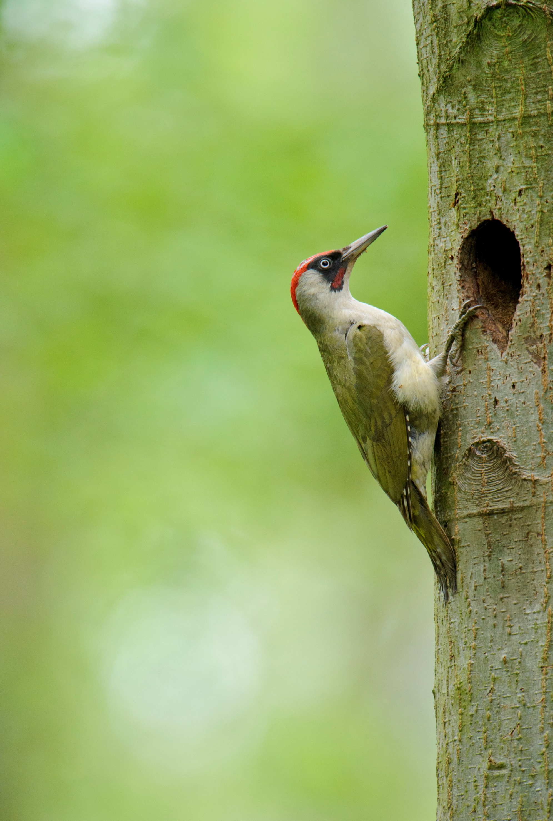
Take Root
Walks, Events and Workshops 2019
Meet at Sevenoaks Nature Reserve, Bradbourne Vale Road, TN13 3DH – free car park
Please wear sensible clothing as we will be outdoors as much as possible!

Health walks
Health walks were developed to aid people to meet the recommended 150minutes of moderate exercise a week. You’ll get your heart pumping, your lungs oxygenated and your cheeks rosy, as well as being able to have a chat with fellow walkers! These are inclusive walks so no matter your speed, you will always have company It’s whatever moderate is to YOU!
30th May, 25th July, 26th September, 28th November. Meet at 10am
Noticing Nature walks
These walks take a slower pace – allowing us to notice our surroundings, and truly admire the beauty of nature. We’ll be listening to natural sounds, watching the wildlife, and maybe even stop to do some sketching.
25th April, 27th June, 29th August, 24th October, 19th December. Meet at 10am

Coffee Mornings
15th May, 7th August, 20th November. Meet at 11am
Join your fellow Take Root-ers for a drink and a chat at the Visitor Centre – or perhaps even in the wildlife garden if the weather is kind! A range of hot drinks, cold drinks and snacks are available to buy from the visitor centre Starting at 10am.

Workshops
Wildlife ID workshop – 23rd July. More information to follow!
Wild About Gardens Adviser workshop – 17th October. Learn to become a Wildlife Garden advisor for our Wild About Gardens Scheme. For more information – just ask!

Events
Wellbeing festival – 11th June. A variety of activities to experience, designed to improve wellbeing. More information to follow!
Natural Christmas decorations – 10th December. Create 100% plastic free natural Christmas decorations! They look great and are fantastic for the environment More information to follow.

