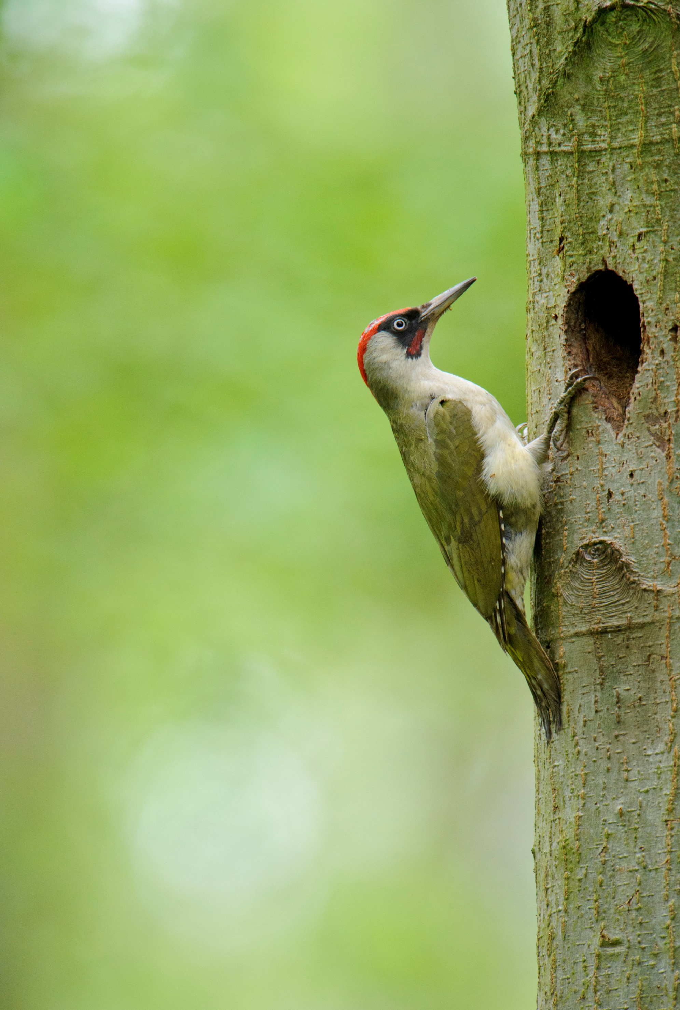
Take Root
Project Programme 2019

Each programme is made up of 6 weekly sessions.
Wednesday morning, 10am – 12pm.
Meet at Sevenoaks Nature Reserve, Bradbourne Vale Road, TN13 3DH – free car park
Please wear sensible clothing as we will be outdoors as much as possible!

Programme 1 – Noticing Nature and Mindfulness
3rd April – 8th May
For the beginning of the Take Root project, we will have a gentle introduction to the Sevenoaks reserve – but taking our time and really noticing the beauty, the sounds, the feel and the atmosphere of the reserve. This will include birdwatching, listening exercises, sketching, yoga, moth ID and being in the present moment.

Programme 2 – Wildlife Monitoring
5th June – 10th July
A major part of our conservation work is to monitor the wildlife on our reserves, as this can show us that our hard work managing the reserves is paying off. Each week we will have a different focus; butterflies, dragonflies, birds, water vole, botany and moths. This is a great way to learn the names of species, ID, the beauty of our British wildlife, and how nature is interlinked to our habitat management.

Programme 3 – Wildlife Gardening
14th August – 18th September
We will be working in the two wildlife gardens at Sevenoaks, learning how to garden with wildlife in mind. You will hopefully pick up some handy tips to use in your own gardens; learning about pollinator friendly plants, animal shelters, bird feeding, organic management, composting and how this will attract wildlife to the garden. There will be a practical element to this programme, giving the opportunity for hand’s on learning!

Programme 4 – Practical Conservation
9th October – 13th November
This will be a practical programme, getting involved with managing the habitats at Sevenoaks. We will be doing scrub cutting, to improve the woodland areas and protect the rare lichen and moss communities. You can do as little or as much of the physical work as you like, and tools will be provided. Please wear suitable clothing and footwear, and bring along some refreshments to keep yourself hydrated!

